Curriculum Vitae

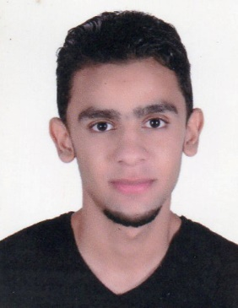

**Personal details:**

Name: Mohammed Abdulzahra Ahmed Maki Ali

Date of Birth: 13/9/2000

CPR Number: 000904872

Marital Status: Single

Home Address: House 1312 Road 521 Block 1205

Mobile: 34144618

**Education:**

Secondary certificate Hamad Town School

**Experiences:**

Sales (3 years in popular market in Isa Town)

Communication

**Interests:**

Sports